Student Performance Prediction System

Project Id: 04

Name : VANSHIKA PARAJAPATI
Class Roll Number: 22
University Roll Number : 2028513
Section and Group: G(G1)

Name : ISHANAYA AGARWAL
Class Roll Number:08
University Roll Number : 2028433
Section and Group: G(G1)

Name : SHAGUN
Class Roll Number:18
University Roll Number : 2028489
Section and Group: G(G1)

- Problem Description 3
- Architecture 4
- Models model 5
- Evaluation metrics used 6
- Preliminary Results and Visualizations 7-8
- References 9

- Problem Description
The Agricultural Region Clustering System is a Machine Learning-based analytical project designed to group agricultural regions based on environmental conditions and crop yield characteristics.
Agriculture depends on multiple factors such as rainfall, temperature, soil nutrients, irrigation, and farming practices. Analyzing these factors individually is difficult and time-consuming. This project solves that problem by using K-Means Clustering, an unsupervised machine learning algorithm, to automatically group regions with similar characteristics.
The dataset consists of 20 region-level features, including:
- Average rainfall (mm)
- Average temperature (°C)
- Soil moisture (%)
- Soil pH
- Nitrogen, phosphorus, potassium content
- Irrigation coverage (%)
- Crop area (hectares)
- Fertilizer & pesticide usage
- Sunlight hours, humidity (%)
- Altitude, wind speed
- Groundwater level
- Crop diversity index
- Mechanization score
- Historical yield variance
- Average crop yield
The main objective is to:
- Identify similar agricultural zones
- Help in better decision-making for farming strategies
- Improve crop productivity

- Architecture

System Workflow:
- Data Collection
Structured dataset of agricultural features is used.
- Exploratory Data Analysis (EDA)
  - Understand data distribution
  - Detect missing values
  - Analyze correlations
- Data Preprocessing
  - Handle missing values (mean imputation)
  - Normalize data using StandardScaler
- Feature Selection
  - Apply backward feature elimination
  - Select most relevant features
- Clustering (K-Means)
  - Determine optimal K using Elbow Method
  - Apply K-Means algorithm
- Evaluation
  - Use Silhouette Score
- Visualization
  - Heatmaps
  - PCA-based cluster plots
- Prediction
  - Assign cluster labels to new data

- Models Used(Applied/ Planned) Give a brief introduction of the models used

K-Means Clustering
K-Means is an unsupervised machine learning algorithm used to divide data into clusters based on similarity.
- It groups regions into K clusters
- Each cluster has a centroid
- Data points are assigned to the nearest centroid

Sequential Feature Selector
Used for backward feature elimination:
- Removes less important features
- Improves clustering efficiency

Principal Component Analysis (PCA)
- Reduces high-dimensional data into 2D
- Helps visualize clusters clearly

- Evaluation metrics used

1. Elbow Method
Used to find the optimal number of clusters (K).
- Plots WCSS (Within Cluster Sum of Squares)
- The "elbow point" indicates best K

2. Silhouette Score
Measures how well clusters are formed.
- Value ranges from -1 to 1
- Higher value = better clustering
Formula concept:
- Measures distance within cluster vs other clusters

5. Preliminary Results and Visualizations
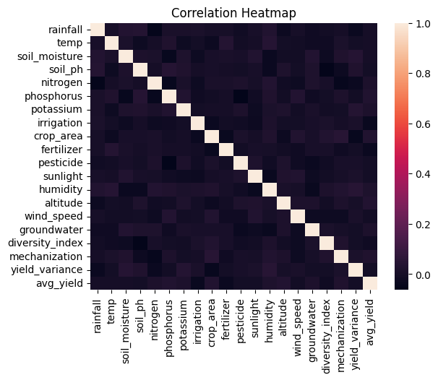

FIG1. Correlation HeatMap

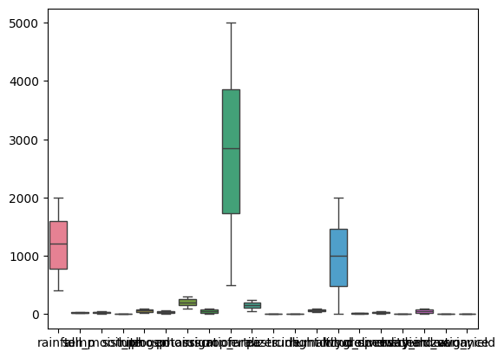

FIG2. Boxplot for Outliers

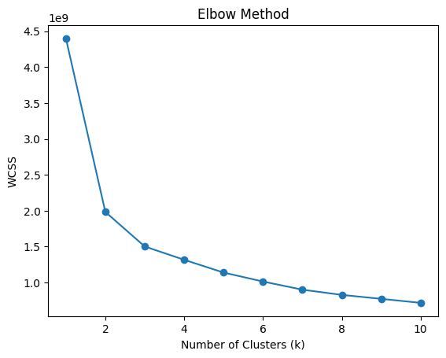

FIG3. Elbow method

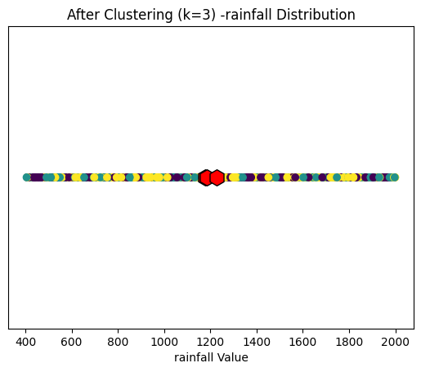

FIG4. After clustering (k=3)

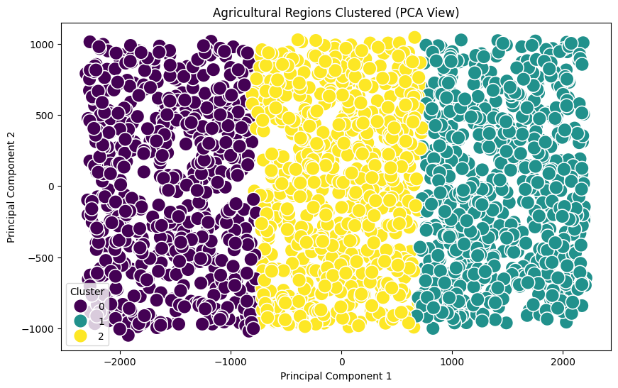

FIG5. PCA for Visualization

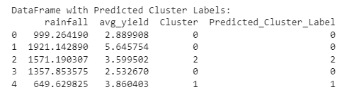
FIG6. Predicted Cluster

6. References:
Books:
- Let Us Python – Yashavant Kanetkar

Online Resources:
  - GeeksforGeeks – https://www.geeksforgeeks.org/
  - TutorialsPoint – https://www.tutorialspoint.com/cprogramming/index.htm
  - Stack Overflow – https://stackoverflow.com

